How to Manually Copy or Move an AutoCAD Plant 3D SQL Express/Standard/Enterprise Project

|  |  |
| --- | --- |
| C:\Users\tynerd\Pictures\autocad-plant-3d-2016-badge-2048px.jpg | http://greenwireit.com/wp-content/uploads/2013/05/sql-server-express1.png |

Dave Tyner  
Autodesk Product Specialist  
dave.tyner@autodesk.com

Plant 3D ships with a tool called *PnPProjectMaintenance.exe* which will copy/move a project. Therefore, it is not necessary to complete all of the steps below in order to move or copy a project. If you do not have an understanding of databases, it is recommended that you use PnPProjectMaintenance.exe to accomplish the database portion of the tasks below. If you do use PnpProjectMaintenance.exe, you can skip to the Windows Powershell portion of this document on page 12.

I mention a few times to **back up your databases and Plant 3D project files** before you begin. Totally not kidding, make sure you do that. ☺

## What you will need:

SQL Express/Standard/Enterprise - I am using 2102 but this should work on 2008 as well  
SQL Server Management Studio  
Microsoft PowerShell  
AutoCAD Plant 3D

## What you will need to know:

**MAKE A BACKUP OF YOUR PROJECT FILES AND PROJECT DATABASES BEFORE COMPLETING THE STEPS OUTLINED IN THIS PROCEDURE. THIS IS ALL CAPS AND BOLD FOR A REASON. YOU HAVE BEEN WARNED.**

|  |
| --- |
| *Code snippets look like this* |

Make sure no one is in the project you are copying/moving

## Let’s Go!

## Step 1 – Log into SQL Server Management Studio as Administrator

My instance is set to mixed mode so I log in with SQL credentials

[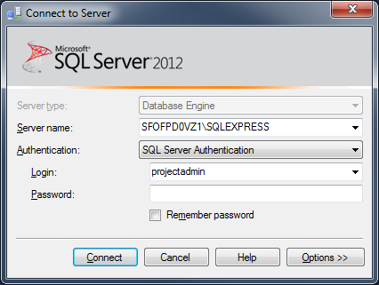](http://www.davetyner.com/wp-content/uploads/2015/09/sqlLoginMixedMode.png)

## Step 2 – Detach the Databases

Identify databases to copy or move and **MAKE SURE NO ONE IS IN THEM** before continuing.

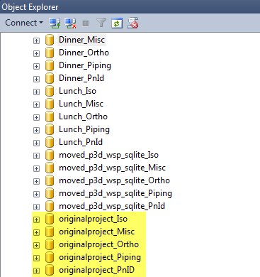

Create a **New Query** tab and paste this query into it. Replace <DATABASE_PREFIX> in the following SQL statement with the prefix of the databases you wish to copy.

|  |
| --- |
| USE master;  GO  EXEC sp_detach_db  @dbname = N'<DATABASE_PREFIX>_Iso';  GO  EXEC sp_detach_db  @dbname = N'<DATABASE_PREFIX>_Ortho';  GO  EXEC sp_detach_db  @dbname = N'<DATABASE_PREFIX>_PnID';  GO  EXEC sp_detach_db  @dbname = N'<DATABASE_PREFIX>_Piping';  GO  EXEC sp_detach_db  @dbname = N'<DATABASE_PREFIX>_Misc';  GO |

When everything is good to go, press **F5** or **Execute**

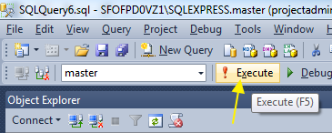

## Step 4 – Copy Project Files

Copy your Plant 3D project files to the new location. This step can be executed at any time.

[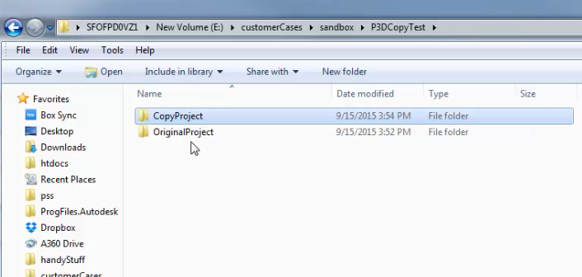](http://www.davetyner.com/wp-content/uploads/2015/09/copy_project_files.png)

## Step 5 – Copy SQL MDF and LDF Database Files

[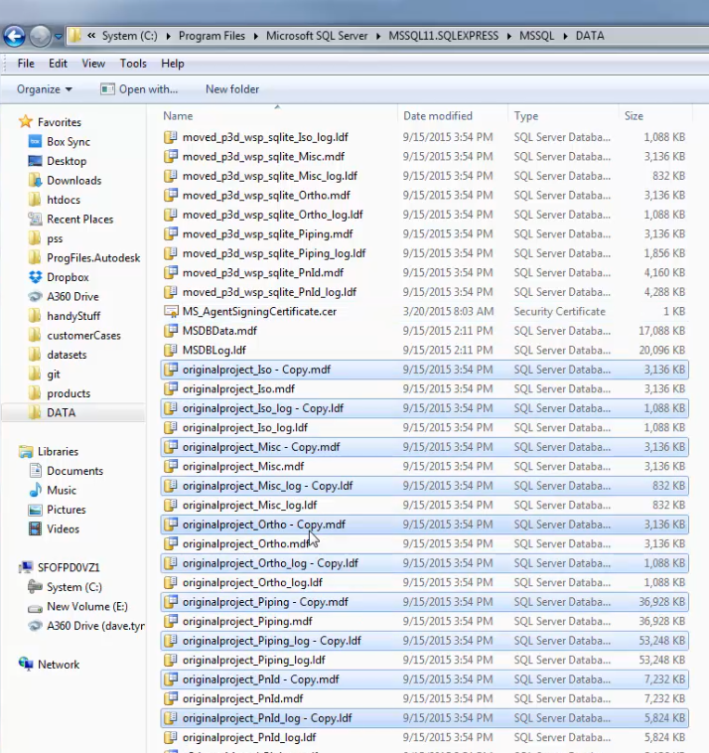](http://www.davetyner.com/wp-content/uploads/2015/09/copydatabases.png)

Create copies of your project databases by copy/pasting your original database .mdf and .ldf files. The default directory for SQL Express databases is:

**C:\Program Files\Microsoft SQL Server\MSSQL11.SQLEXPRESS\MSSQL\DATA**

Rename the database prefix to the desired name for all 5 databases and all 5 database ldf files. For me that is “copyproject”

* copyproject_Iso.mdf
* copyproject_Iso_log.ldf
* …Piping…
* …PnPid…
* …Misc…
* …Ortho…

Here is an image showing the renamed databases. There should be 10 total, one .mdf and one .ldf for each project database.

[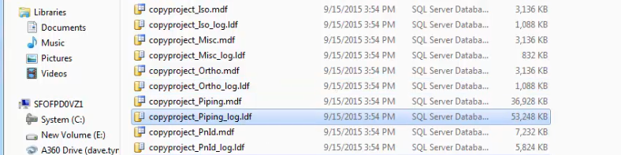](http://www.davetyner.com/wp-content/uploads/2015/09/copydatabasesFinished.png)

## Step 6 – Reattach the Databases

Open SQL Management Studio and paste the query below into a New Query tab.

|  |
| --- |
| USE master;  GO  CREATE DATABASE "<DATABASE_PREFIX>_Iso"  ON (FILENAME = 'C:\Program Files\Microsoft SQL Server\MSSQL11.SQLEXPRESS\MSSQL\DATA\<DATABASE_PREFIX>_Iso.mdf'),  (FILENAME = 'C:\Program Files\Microsoft SQL Server\MSSQL11.SQLEXPRESS\MSSQL\DATA\<DATABASE_PREFIX>_Iso_log.ldf')  FOR ATTACH;  GO  CREATE DATABASE "<DATABASE_PREFIX>_Misc"  ON (FILENAME = 'C:\Program Files\Microsoft SQL Server\MSSQL11.SQLEXPRESS\MSSQL\DATA\<DATABASE_PREFIX>_Misc.mdf'),  (FILENAME = 'C:\Program Files\Microsoft SQL Server\MSSQL11.SQLEXPRESS\MSSQL\DATA\<DATABASE_PREFIX>_Misc_log.ldf')  FOR ATTACH;  GO  CREATE DATABASE "<DATABASE_PREFIX>_Piping"  ON (FILENAME = 'C:\Program Files\Microsoft SQL Server\MSSQL11.SQLEXPRESS\MSSQL\DATA\<DATABASE_PREFIX>_Piping.mdf'),  (FILENAME = 'C:\Program Files\Microsoft SQL Server\MSSQL11.SQLEXPRESS\MSSQL\DATA\<DATABASE_PREFIX>_Piping_log.ldf')  FOR ATTACH;  GO  CREATE DATABASE "<DATABASE_PREFIX>_PnID"  ON (FILENAME = 'C:\Program Files\Microsoft SQL Server\MSSQL11.SQLEXPRESS\MSSQL\DATA\<DATABASE_PREFIX>_PnID.mdf'),  (FILENAME = 'C:\Program Files\Microsoft SQL Server\MSSQL11.SQLEXPRESS\MSSQL\DATA\<DATABASE_PREFIX>_PnID_log.ldf')  FOR ATTACH;  GO  CREATE DATABASE "<DATABASE_PREFIX>_Ortho"  ON (FILENAME = 'C:\Program Files\Microsoft SQL Server\MSSQL11.SQLEXPRESS\MSSQL\DATA\<DATABASE_PREFIX>_Ortho.mdf'),  (FILENAME = 'C:\Program Files\Microsoft SQL Server\MSSQL11.SQLEXPRESS\MSSQL\DATA\<DATABASE_PREFIX>_Ortho_log.ldf')  FOR ATTACH;  GO |

Replace **<DATABASE_PREFIX>** with the name of your database prefix. The find/replace shortcut in SQL Management Studio is Ctrl+H

[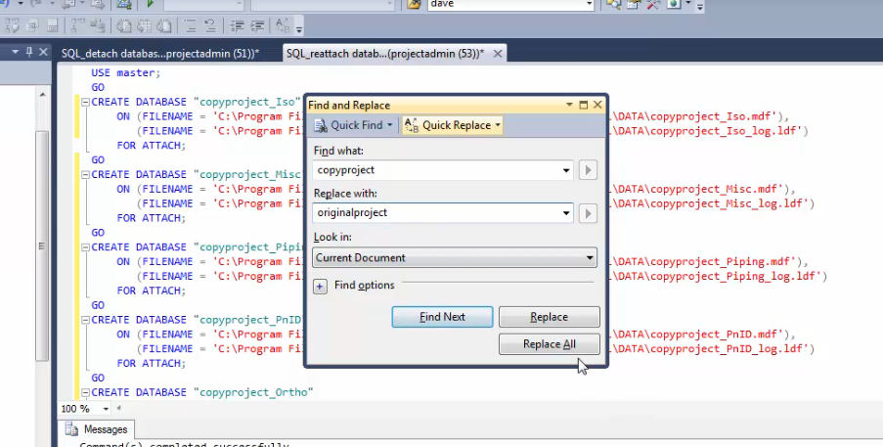](http://www.davetyner.com/wp-content/uploads/2015/09/reattach_orignialDB.png)

Figure 1 Find and Replace dialog

**Remember your original database is still detached so run the same procedure as above to reattach.**

Your databases are now reattached! Next we will update some records in a few tables to reflect the new project’s path.

## Step 7 – Replace File Paths in Piping/PnID Table

|  |
| --- |
| /*Example: Update <YOURDATABASEPREFIX>_piping.dbo.pnpdrawings set path = replace(‘<OLDPATH>’,’<NEWPATH>’)  */  UPDATE copyproject_piping.dbo.PnPDrawings  set Path = replace(Path, 'E:\customerCases\sandbox\P3DCopyTest\OriginalProject\Plant 3D Models\', 'E:\customerCases\sandbox\P3DCopyTest\CopyProject\Plant 3D Models\')  GO  select Path from copyproject_piping.dbo.PnPDrawings  GO  UPDATE copyproject_pnid.dbo.PnPDrawings  set Path = replace(Path, 'E:\customerCases\sandbox\P3DCopyTest\OriginalProject\Plant 3D Models\', 'E:\customerCases\sandbox\P3DCopyTest\CopyProject\Plant 3D Models\')  GO  select Path from copyproject_pnid.dbo.PnPDrawings  GO |

You should see the query results showing the correct path.

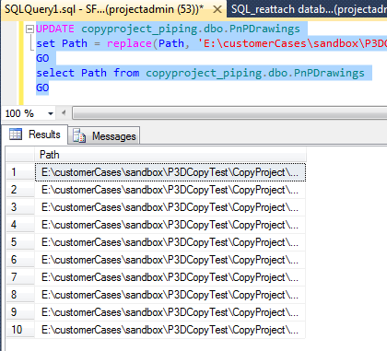

## Step 8 – Update Project Name in Database

|  |
| --- |
| UPDATE copyproject_piping.dbo.PnPProject set project_name = 'Copy Project'  GO  UPDATE copyproject_pnid.dbo.PnPProject set project_name = 'Copy Project'  GO  SELECT project_name from copyproject_piping.dbo.PnPProject  GO |

You should see the query results showing the correct Project Name

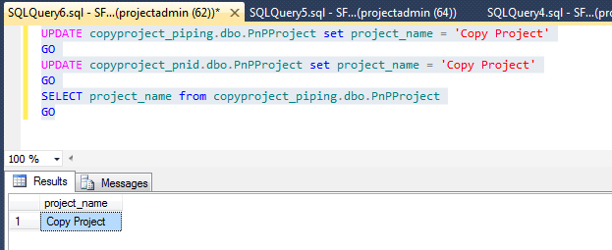

# Use Windows PowerShell to Automatically Replace the Project Path String in the Plant 3D Project XML/DCF Files

## Step 1 - Create the PowerShell script

In Notepad, create a new text file and paste the following code into it

|  |
| --- |
| param( [string]$Find, [string]$Replace, [string]$Path )  gci -Path $Path -recurse | foreach{ (gc $_) -replace $Find,$Replace | sc $_ } |

Save this file as replace.ps1

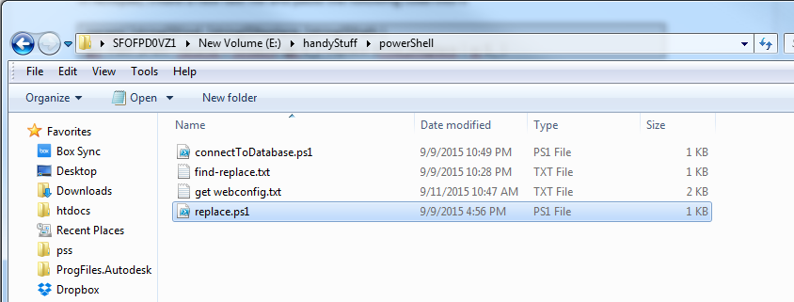

## Step 2 - Call the PowerShell script

Open Windows PowerShell

Navigate to your replace.ps1 file you created in the last step

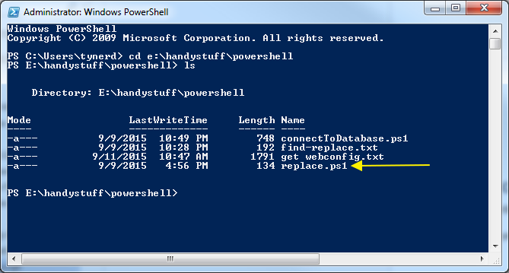

The replace.ps1 script will be called like this:

|  |
| --- |
| *./replace oldProjectPath newProjectPath pathThatContainsXMLFiles* |

For example:

My **old** project is located in ***e:\customerCases\sandbox\P3DCopyTest\OriginalProject***My **new** project is located in ***e:\customerCases\sandbox\P3DCopyTest\CopyProject***

My **old** database prefix is ***originalproject_***My **new** database prefix is ***copyproject_***

Therefore I want to replace all occurrences of **e:\customerCases\sandbox\P3DCopyTest\OriginalProject**  
with **e:\customerCases\sandbox\P3DCopyTest\CopyProject** in all of the xml files. I also want to replace the old database prefixes with the new ones in the .dcf files.

PowerShell uses regular expressions so you will have to escape the \ character. You do this by using \\ in both the **oldProjectPath** string and the **pathThatContainsXMLFiles** string **NOT the newProjectPath** string. Run the script as shown below. I am using the forward slash “/” instead of the backslash but that is not required here. **There is no undo on this step, make sure you have backed up your project files before this step!!**



## Step 3 – Change the project name in the Project.XML file

This one I am doing manually. Simply open the project.xml file in your project root and change this line

<ProjectName>OriginalProject</ProjectName>  
to this  
<ProjectName>CopyProject</ProjectName>

### That’s it folks! If you followed each step of this procedure you should now have a fully functioning copy of your project.